InterviewBuddy

Project Execution and Tracking

Version 1.0

Revision History
Date | Version | Description | Author
16/Oct/26 | 1.0 | Initial version for Project Execution and Tracking Report | Dao Ngoc Chung Nguyen

Table of Contents
1. Setting Up Tools & Infrastructure 4
2. Tracking Progress 4
3. Reporting Status 4
4. Collaboration and Teamwork 4

Project Execution and Tracking

Setting Up Tools & Infrastructure
To ensure efficient workflow and collaboration, the InterviewBuddy team has established a comprehensive toolchain adapted to current project conditions:
- Jira Software: Used for Scrum project management, sprint planning, and weekly task assignment.
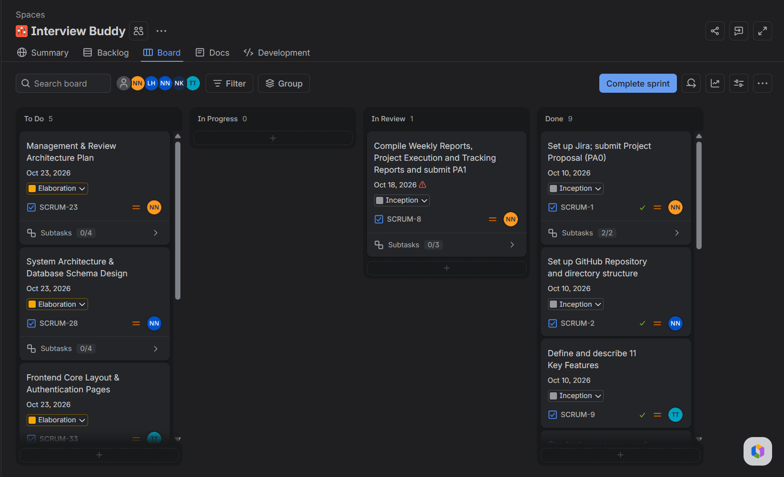
- Messenger (Temporary Channel): Used as the primary daily communication channel for quick updates and problem-solving while waiting for the instructor to provision the official Slack workspace.
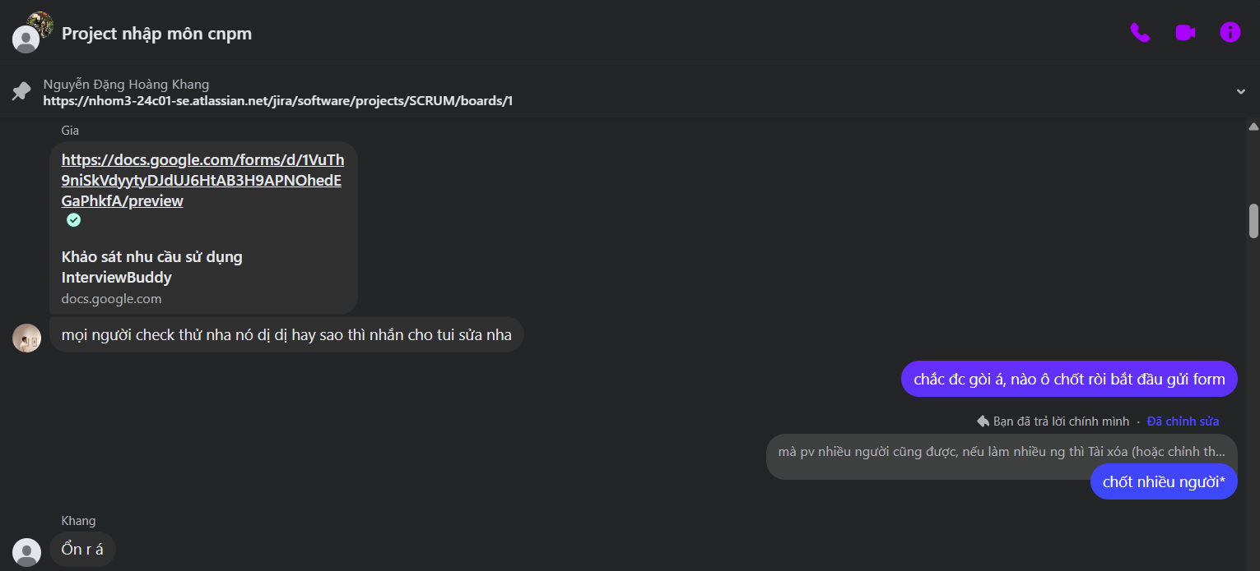
- GitHub: Used for source code and document version control (/docs, /src, /pa).
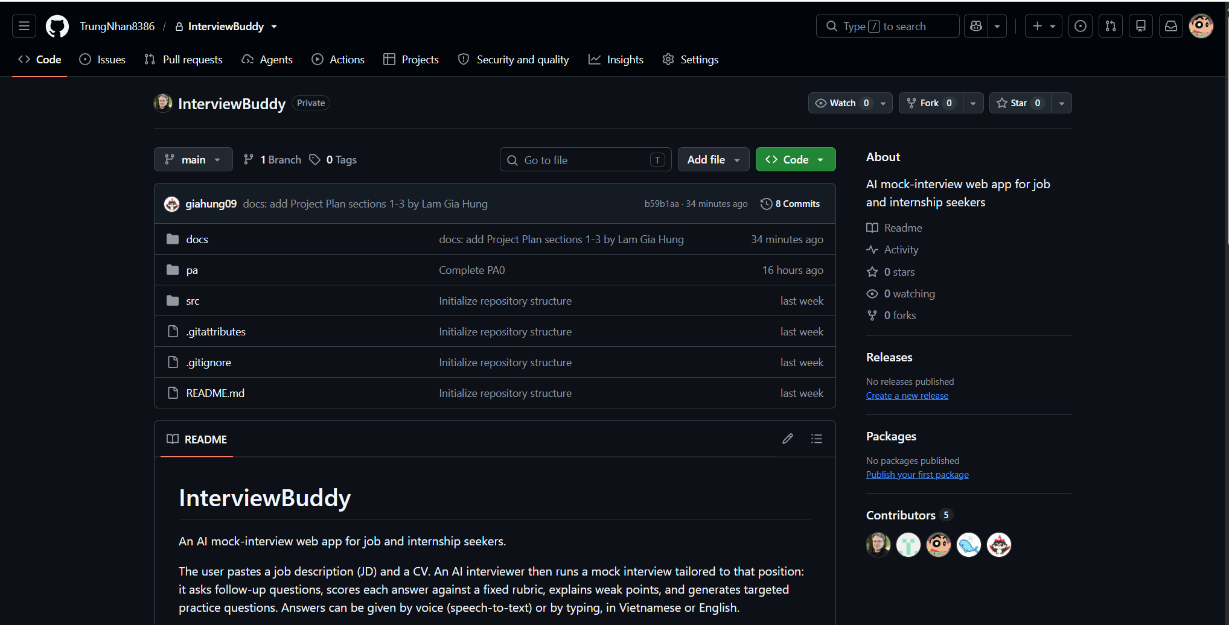
- Google Drive & Google Workspace: Used for centralized file storage and real-time collaborative editing of project documentation (Project Plan, Vision Document, etc.).
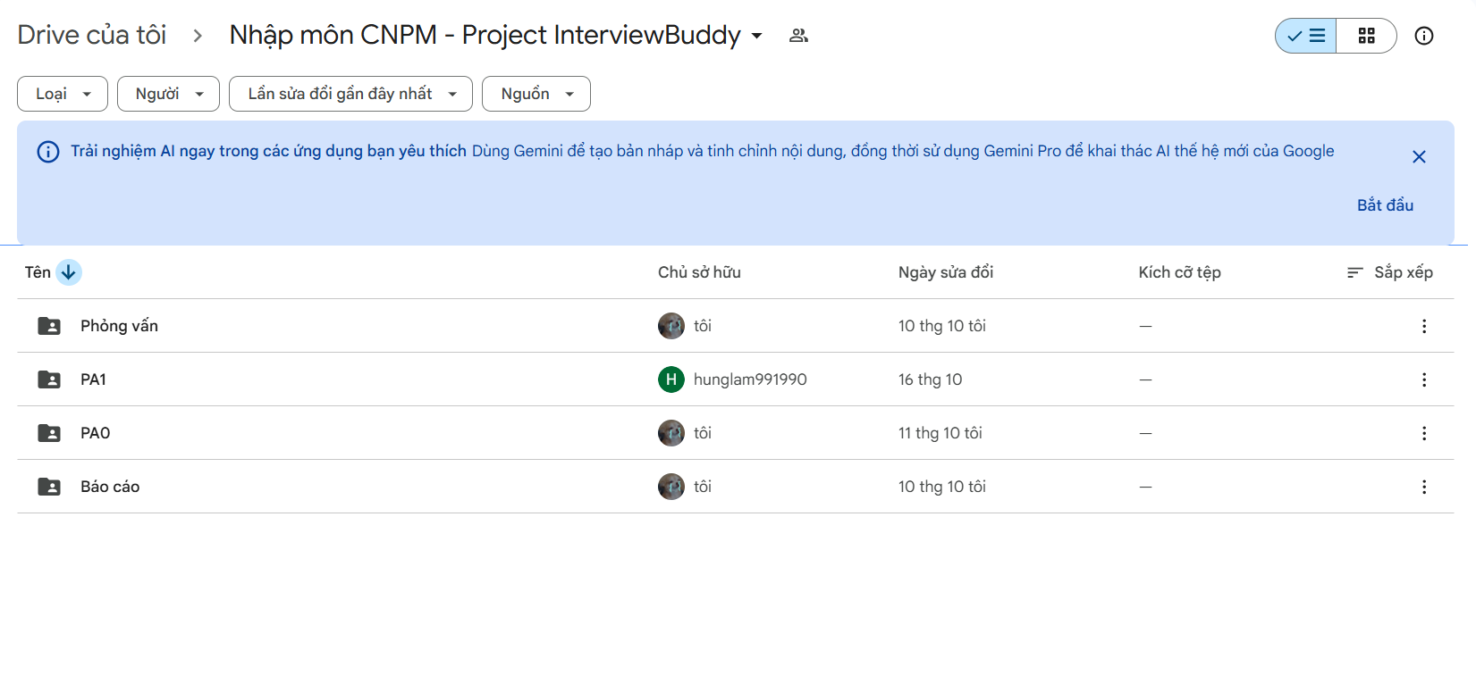

Tracking Progress
The team strictly follows the Scrum framework. The project is divided into 3 Phases and 5 Sprints. For PA1 (Sprint 1 - Inception Phase), the tracking workflow is defined as follows:
- Task Lifecycle: Tasks are created in the Backlog, assigned to specific members (Ngoen, Nhan, Tai, Hung, Khang), and moved across the Jira Board (To Do ➔ In Progress ➔ In Review ➔ Done).
- Sprint Roadmap: All PA1 artifacts (Vision, Project Plan, UI, Reports) are tracked as epic/tasks with explicit Due Dates and Assignees to prevent bottlenecks.
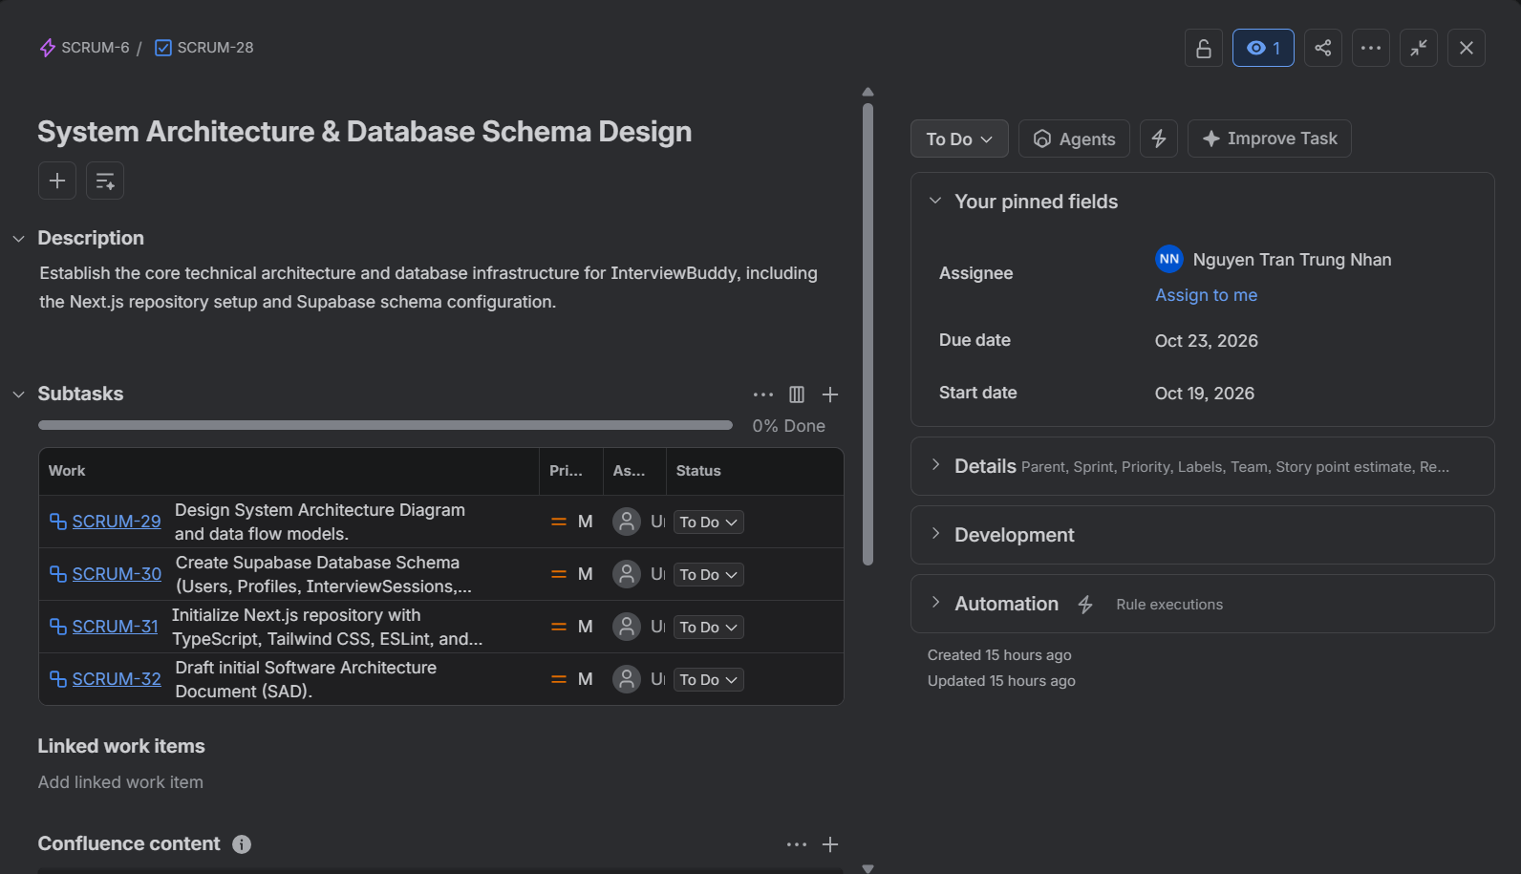

Reporting Status
Project status is monitored and documented weekly by the Group Leader to ensure complete transparency:
- Weekly Reports: The team compiles formal Status Assessment documents every week (InterviewBuddy_ Weekly_Report_W1_v1.1.docx and InterviewBuddy_ Weekly_Report_W2_v1.0.docx).
- Content: Each report explicitly details the Done Tasks (with Jira screenshots), Todo Tasks, and active Issues/Dependencies for every individual member.
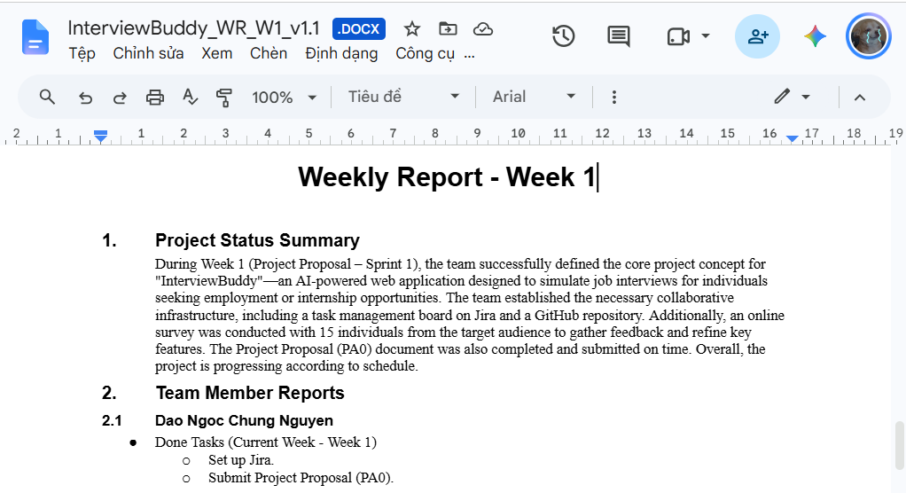

Collaboration and Teamwork
Team collaboration is maintained through synchronized workflows and a strict quality assurance process:
- Final Document Review: Drafts (e.g., Project Plan, Vision Document) are shared on Google Drive by Hung and Nhan. The Group Leader (Ngoen) takes full responsibility for conducting the final comprehensive review before the submission deadline to ensure absolute consistency between Requirements and UI designs.
- Git Version Control: Members use Git commits to push document updates to the repository, ensuring all changes are traceable.
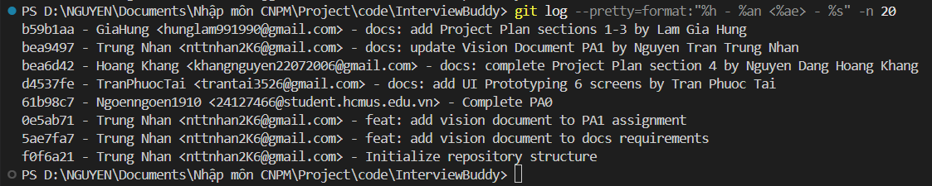
- Meeting & Problem Solving: Team blockers and technical issues are immediately raised and resolved via the Messenger group chat.

